Take Home Exam04B: Activation Energy (Arrhenius Plots)

Assigned: 04/21/2022 (Thursday)

Due (as pdf by email) 04/26/2022 (Tuesday-before 5 PM)
(ii) Please send your submission via email starting with HWExam04B in the subject line.

Inputs:
and, also

04B.1
Data for solid-state diffusion in copper is given in the figure just below (1973, J. Physical Chemistry)
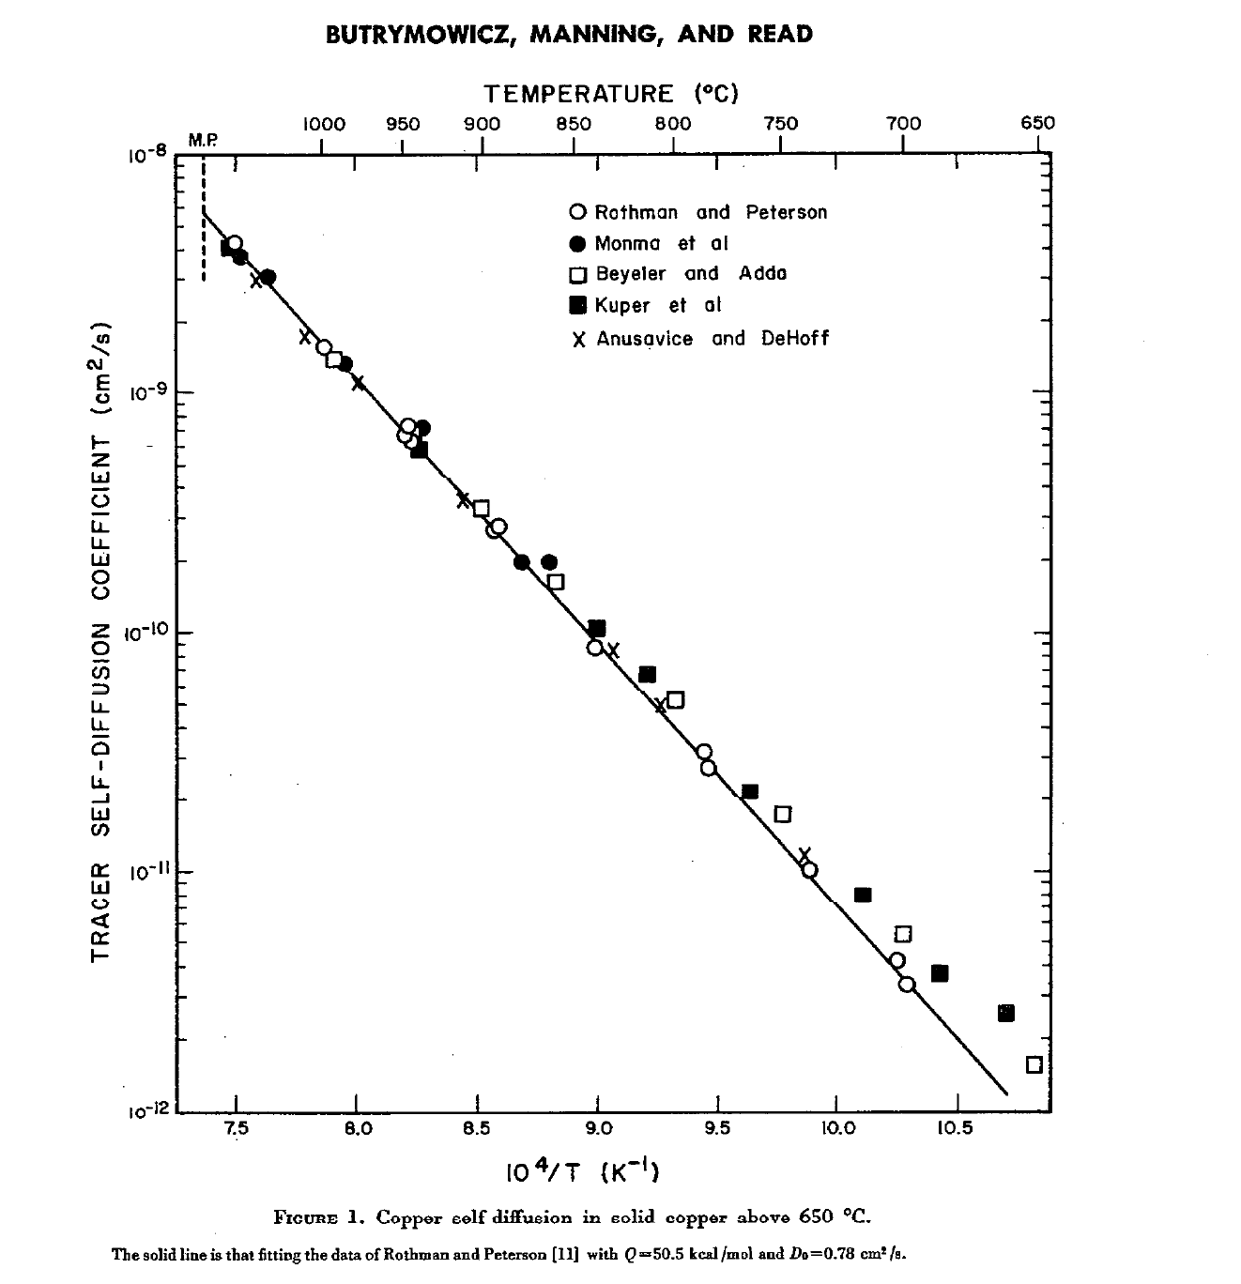
Note that the data have a good straight line fit above 850 ºC (at lower temperature the data deviate towards a mechanism with a lower activation energy - we will discuss this later).
Calculate (graphically and by hand-calculation) the activation energy in units of kJ/mol at 850ºC and above.
04B.2
Calculate the factor for the increase in the diffusion coefficient as the temperature increases from 850 ºC to 900 ºC.

04B.3
What is the value for the diffusion coefficient of copper at its melting point in units of m²s^{–1}.
Noting that the diffusion coefficient for many metals at their melting point is approximately the same, and that the activation energy for diffusion in aluminum is one half of the activation energy for diffusion in copper (referring to the data in the above figure), in this same figure draw a line for the expected diffusion coefficient for solid-state diffusion in aluminum.

